**1. Introduction**

**Project Title: Marine Drive Road**

**Project Members:**

1. DAS, PROMA 19-39625-1
2. AHMED, SK.SHIHAB 19-39575-1
3. SHANTO,MAJHARUL ISLAM 19-39585-1
4. SHOHAN,MD SHOHANUL ISLAM 19-39613-1

**2. BACKGROUND**

Marine Drive Road captures the scenic atmosphere of a marine drive road and its surroundings. In our project there are mountains and in surroundings there are cars driving through the road, there are ships in the ocean.

In our project there are moving car, moving ships, birds, sun ,night and day view which makes our mountain scenario more beautiful.

**3.** **Methodology**

-Background:

For all the background objects (Road, Road lines, Border, Sky, River, Ship) we have used GL_POLYGON_BIT and as for data type we have chosen float. We have used glColor3f () function to add colours to our objects.

For Hills and birds, we have used GL_TRIANGLES and as for data type we have chosen float.

For Sun, we have used GL_TRINANGLE_FAN and constructed a function void circle and void sun then we called it from display function.

For Car, we have used GL_TRIANGLES AND GL_POLYGON_BIT and as for data type we have chosen float.

For movement of those object we used void UPDATE() and void HANDLEKEYPRESS () function ,after that we call it from main function by using GLUTTIMERFUNC().

**4.Significance of The Project**

By doing this project, we are learning to draw objects, to move, to make the object bigger & smaller. Learning to draw circles without using any pre-defined function. Learning to use the handler function to take input from keyboard. This will help us in the future **“OpenGL”** projects. It will help us in the Game development. We will also be able to make games with **“OpenGL”.**

**5. Conclusion**

Our project is about Marine Drive Road and we successfully completed our project and rest of the functionalities were properly implemented. In our project we tried to show beautiful scenario of the marine drive road and also the surroundings of the roads. For making our marine drive road scenario more beautiful we added beautiful mountains and ships in the ocean. We have various movement functionality of car, ship and birds. We used the concept of translation on our learnings.

This are the key function to see the whole project perfectly-

Press ‘s’- to start the ship and flying of the birds.

Press ‘e’- to stop the ship and the birds.

Press ‘b’- to start the car

Press ‘f’- to stop the car

Press ‘x’ – for movement of sun

Press ‘n’- night view

**6 Screen-Shot of The System**

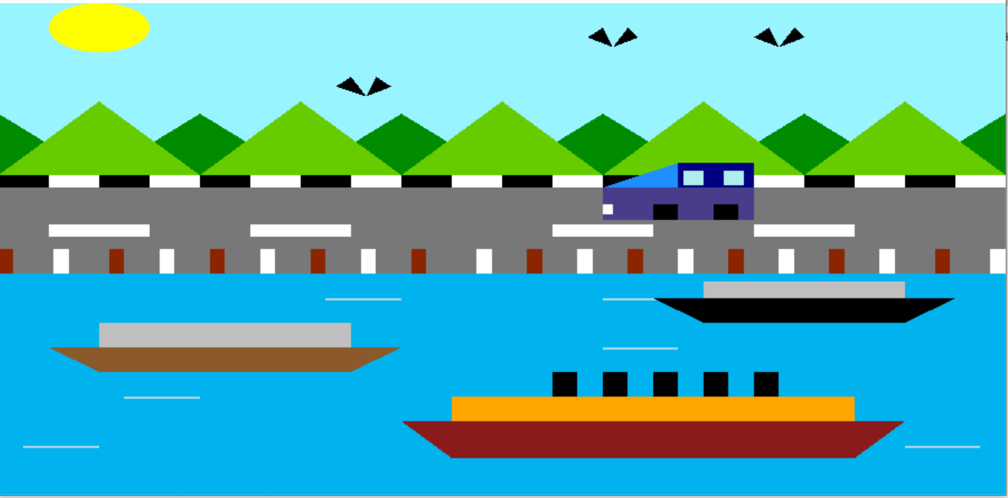

**Screenshot 1 – Full Picture of project**

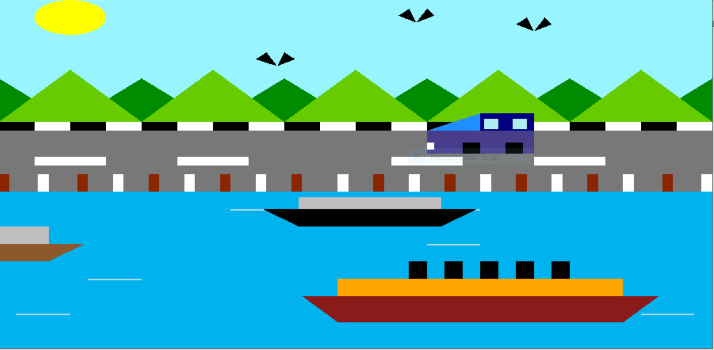

**Screenshot 2 – Movement of ship**

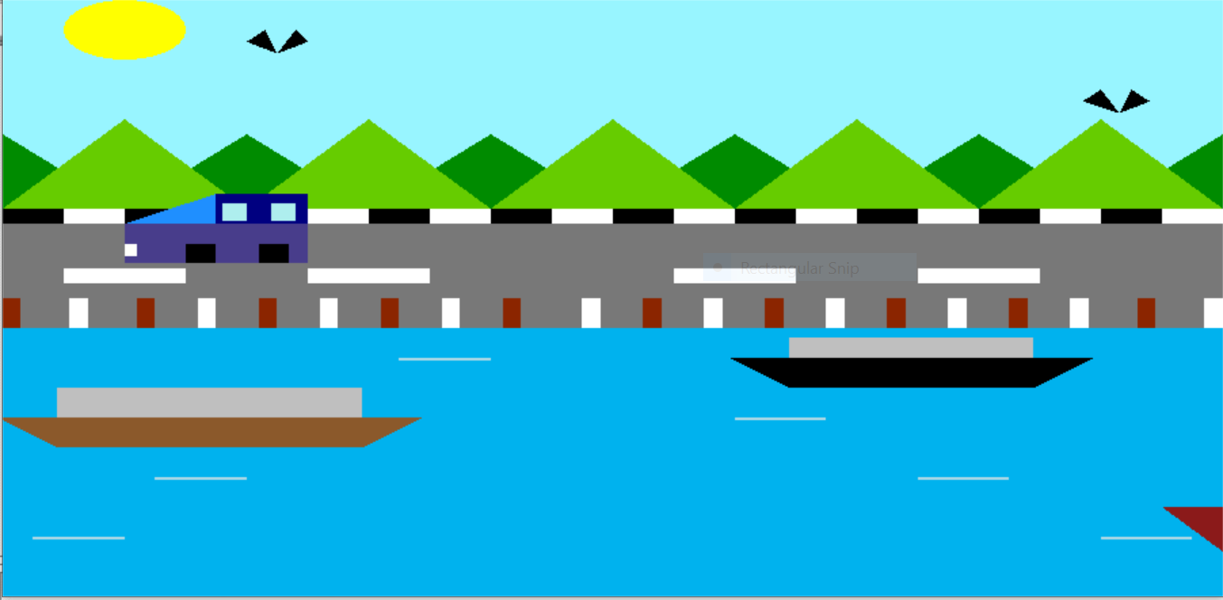

**Screenshot 3- Movement of car & bird**

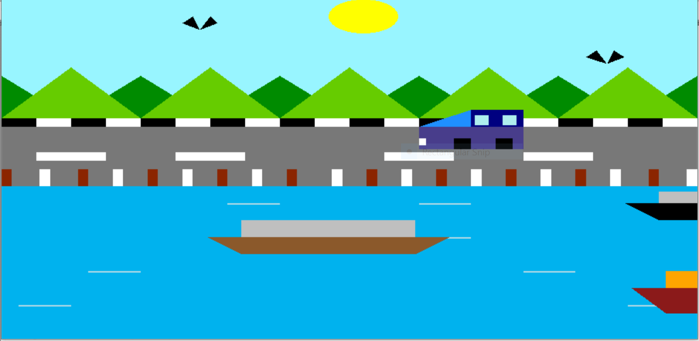

**Screenshot 4 – Movement of sun**

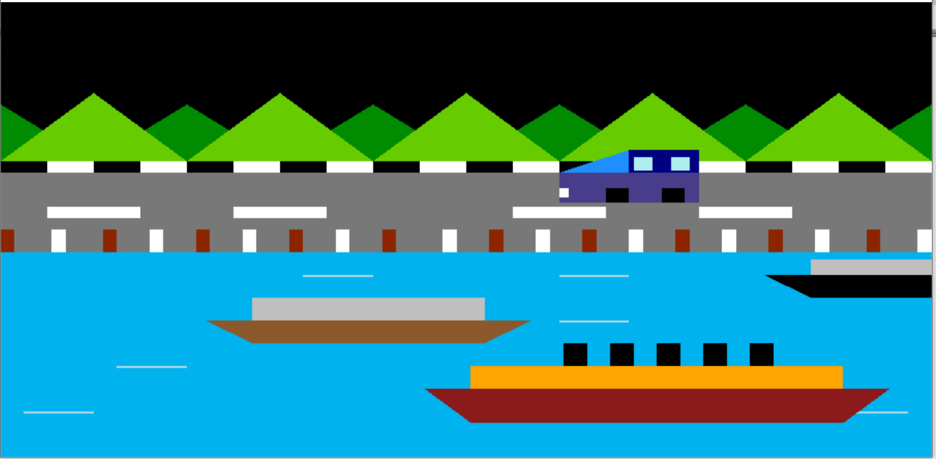

**Screenshot 5- Night view**